**US**

**ABOUT**

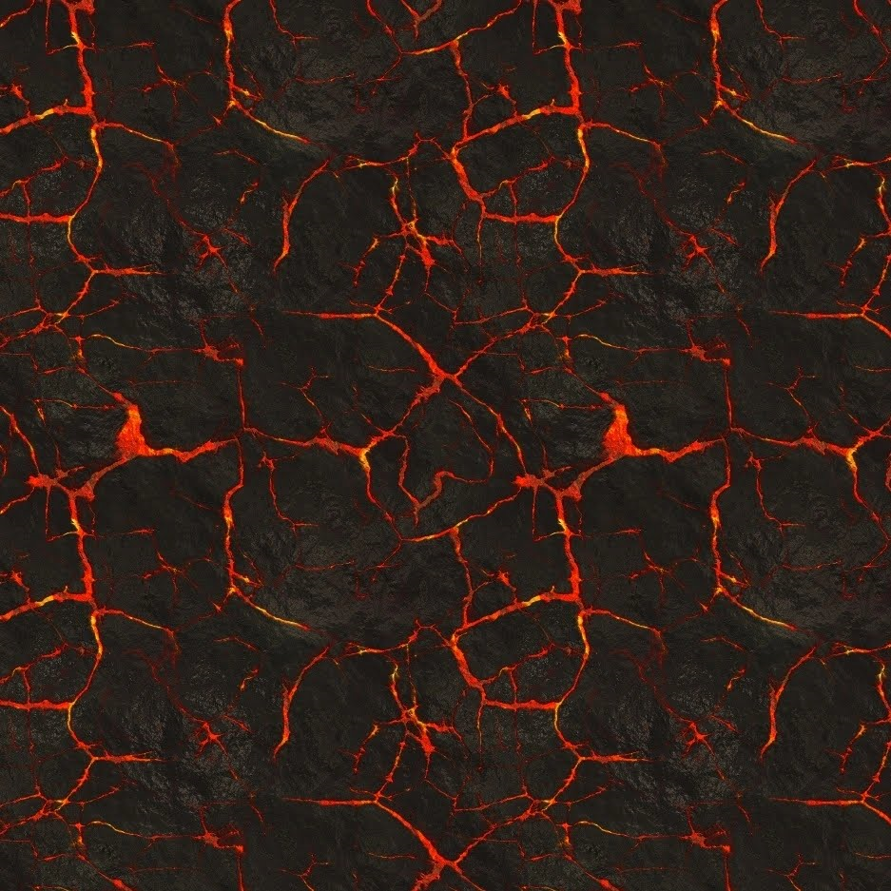

Rare Metals Explorers (RME) cc is a Namibian registered close corporation, and it is one of the trusted consultancies for mineral exploration (green field) and mining (brown fields) in the country. It was incorporated during the fall of year 2013 and has gained a wealth of experience over the years, exploring for a variety of commodities ranging from base and rare metals, industrial minerals, dimension stones, as well as precious and semi-precious stones.

**Values** 

**Management** 

**US**

Our passionate and proficient team of geologists have managed both private and state funded projects and RME proudly handled the geological aspects of the Lofdal REE deposit from 2013 to October 2017.

Like the name implies we are specialists for green technology metals such REEs and Lithium.

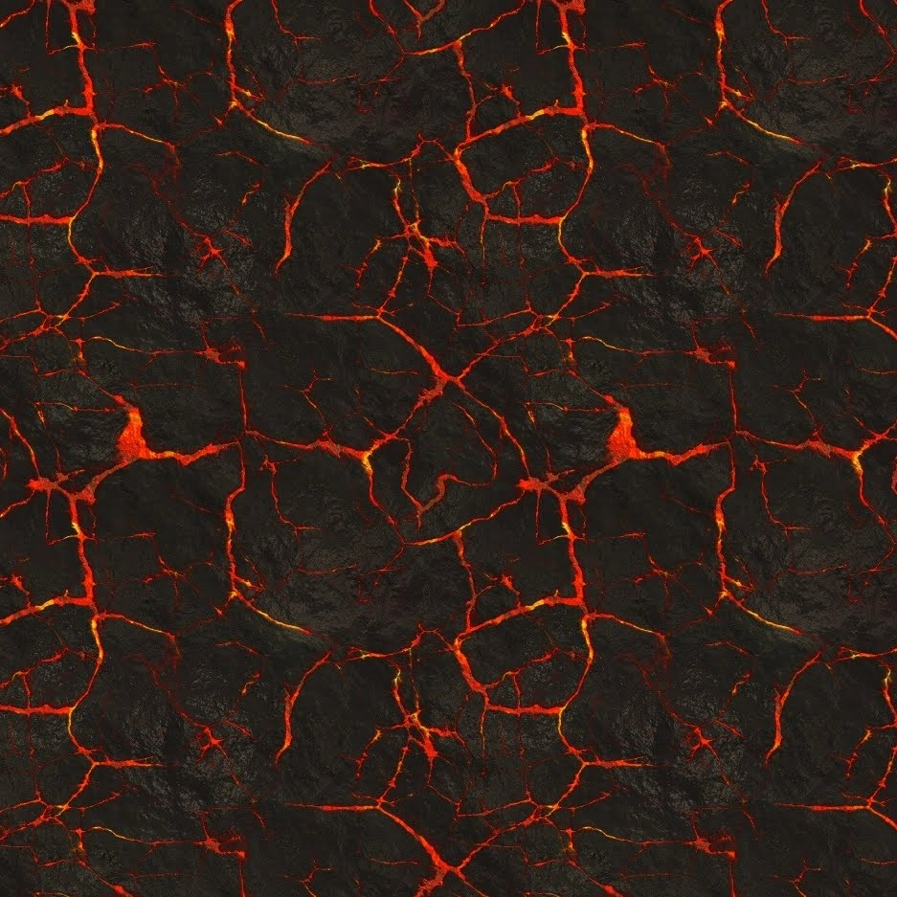

**Corporate Resume**



**Management**



**Gideon K Haingura:** **[Member]**

MSc GIS & RS, B.Sc. (Hons) Geology, ArcGIS, R Cert, Snr.Pr.Nat.Sci.

GIDEON K HAUNGURA’S PHOTO

Mr. G.K Haingura is a founding and managing member who at the time of RME’s inception was working as a consulting exploration geologist for Namibia Rare Earths Inc (now Namibia Critical Metals Inc.), at the Lofdal HREE project. He has over 10 years of consulting experience in the minerals exploration and offers his expertise independently of RME to the

Namibian Ministry of Defence. Gideon is also a founding and managing member of M&D Tours Transfer, as well as Geotrend & Research Data Solutions.

**Management**

**Bonifacius K Katanga:** **[Member]**



* WIA Gold, Navachab Gold Mine, Uis Tin Mine, Epembe Nb, Ta deposit, Ondoto/ Swartbooisdrift LREE (discovery), Teufelskuppe LREE, Ongombo Au, Cu, & Ag deposit, Witvlei Cu, Au, & Ag, DOF Cobalt.

SUCCESSFUL PROJECTS

* Lofdal HREE from discovery to PEA.

ACADEMIC

* B.Sc. Chemistry & B.Sc. Geology, ArcGIS cert.

EXPERIENCE

* **Years:** 12 Years.
* **Commodities:** Base & Rare Metals (REE, Lithium), Industrial Minerals, Dimension stones, semi-precious & Precious Stones.

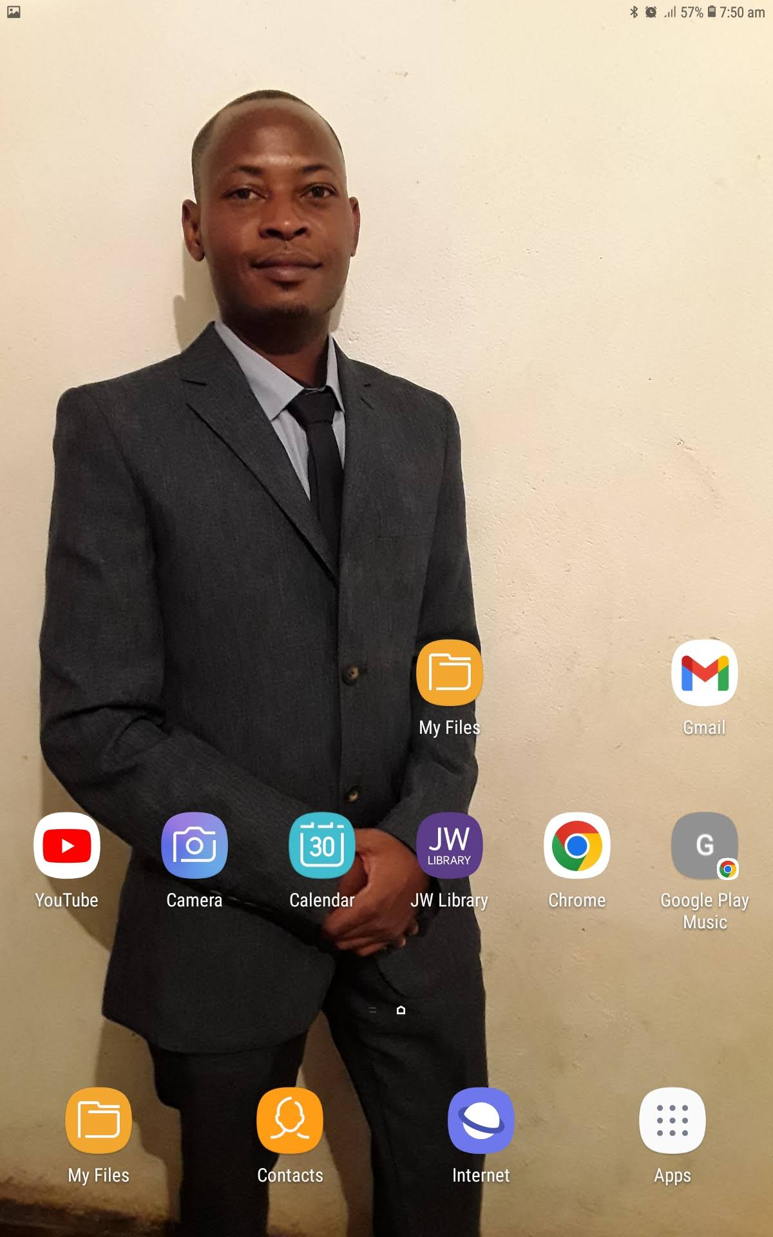

Mr Katanga Bonifacius Katanga began his career as an exploration in 2007, a year he participated in mapping of the Otjozondu manganese seam, geochemical soil sampling at Omitiomire copper deposit, geochemical soil sampling at Berg Aukas mine with BGR, mapping of Rehoboth gold/copper occurrences and as well as Klein Aub copper while a student at the University of Namibia.

In 2010, he joined the Lofdal REE as a junior geologist and participated in the many discoveries of mineralized zones such as LREE rich area 6, Area 4 HREE deposit, Area 5 and more. Mr Katanga progressed from junior geologist to a role of a project geologist and gained a wealth of experience in exploration programme design and execution, targeting, mapping, training of junior personnel, project management and oversight, performance of many mineral exploration activities lead the entire field exploration programme under Rare Metals Explorers cc (RME) from 2014 to 2017.

Year 2018 saw him involved with the DOF Cobalt deposit as a senior exploration geologist working under Gecko Exploration Pty Ltd before moving on to become an independent consultant for Shali Group Pty Ltd, WIA Gold Pty Ltd and Navachab QKR Gold mine.

He joined AfriTin Mining Namibia Pty Ltd (now Andrada Mining Pty Ltd) as an exploration geologist for the company in the fall of 2021 to manage and supervise the entire resource drilling programme targeting Tin and Lithium at Uis Tin Mine.

Mr Katanga currently offers his expertise to several exploration companies through both RME and as an independent consultant.